Personal Financial Planning for Musicians
March 6, 2023

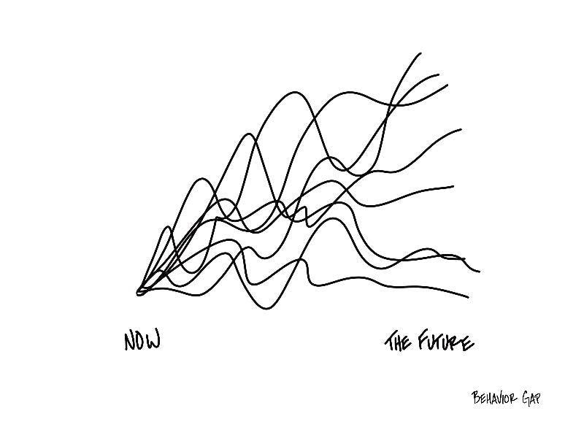
Drawing by Carl Richards

ONCE EVERY SEMESTER:
TRACK EVERY PENNY THAT YOU SPEND & TRACK EVERY PENNY THAT YOU EARN

IN THE NEXT 6 MONTHS:
MAKE A PLAN TO MANAGE – AND PAY OFF – YOUR DEBT
IN THE NEXT 3 MONTHS:
IDENTIFY WAYS TO DECREASE YOUR DISCRETIONARY SPENDING BY 25%

IN THE NEXT 6-12 MONTHS:
OPEN MULTIPLE SAVINGS ACCOUNTS, 1 FOR EACH GOAL

WITHIN 2 YEARS OF GRADUATION:
HAVE AN “EMERGENCY FUND” ACCOUNT, WITH 3-6 MONTHS OF NON-DISCRETIONARY EXPENSES
IN THE NEXT 12 MONTHS, OPEN AN IRA OR ROTH IRA

WITHIN 3 YEARS OF GRADUATION:
ELIMINATE ALL OF YOUR BAD DEBT.

Your Personal Characteristics & Situation

Before you can begin thinking about your future, you need to know where you are today. Briefly identify the characteristics that define your current situation, in order to begin thinking about what your personal, professional and financial futures might look like.

Your Personal Characteristics & Situation

Age:

Family – Spouse? Partner? Children? Parents?:

Other:

Your Graduate School Program

When Do You Expect to Complete School?

Your Future Career Path

Take a shot at articulating your professional expectations here. If you aren’t feeling confident about some of your answers that’s ok. Continuously refining educated guesses about yourself and your situation is what this kind of planning is all about.
What job do you expect to have 1 year after you complete school?

What job do you want to have 5 years after you complete school?

Where do you want to be living 5 years after you complete school?

Where do you want to be living 15 years after you complete school?
What Are Your Values?

Our values are those ideals that are most important to us. You should have already worked through the Values Sort Exercise at https://www.think2perform.com/values#start. Now let’s dig a little deeper, and sort our values into “Personal” values and “Professional” values. We do this to think about the trade-offs we may make between short-term and long-term decisions.

What Are Your Top 5 Personal Values?

- _________________________________
- _________________________________
- _________________________________
- _________________________________
- _________________________________

What Are Your Top 5 Professional Values?

- _________________________________
- _________________________________
- _________________________________
- _________________________________
- _________________________________

The list below provides some popular values. Feel free to define your own values are not in this table.

Order | Fame | Faith | Pleasure | Decisiveness
Wealth | Power | Achievement | Spirituality | Flexibility
Honesty | Leadership | Competition | Philanthropy | Friendship
Freedom | Ethics | Money | Autonomy | Meaningful Work
Relationships | Cooperation | Excellence | Safety | Religion
Community | Competence | Creativity | Adventure | Family
Integrity | Recognition | Happiness | Play | Status
Stability | Health | Fairness | Diversity | Privacy
Challenges | Change | Service | Environment | Helping Others
Independence | Security | Excitement | Loyalty | Education

What Are Your Goals?

Our values and personal characteristics define where we are today. Our goals define where we want to be in the future. Most of us have distinctly different personal and professional goals – and those goals will change and evolve over time. Think about your goals, what your personal and professional goals are.

What Are Your Top 5 Personal Goals for the Next 3 Years?

- _______________________________________________________________________
- _______________________________________________________________________
- _______________________________________________________________________
- _______________________________________________________________________
- _______________________________________________________________________

What Are Your Top 5 Personal Goals for the Next 10 Years?

- _______________________________________________________________________
- _______________________________________________________________________
- _______________________________________________________________________
- _______________________________________________________________________
- _______________________________________________________________________

What Are Your Top 5 Professional Goals for the Next 3 Years?

- _______________________________________________________________________
- _______________________________________________________________________
- _______________________________________________________________________
- _______________________________________________________________________
- _______________________________________________________________________

What Are Your Top 5 Professional Goals for the Next 10 Years?

- _______________________________________________________________________
- _______________________________________________________________________
- _______________________________________________________________________
- _______________________________________________________________________
- _______________________________________________________________________

What Does Retirement Look Like to You?

For most of us, retirement eventually becomes a major part of our future planning. Of course, it’s probably a long way away for you and you have an entire life to live before you retire. But thinking about what retirement looks like to you – and what you want your retirement to be – can help you think about how you live that life and what career options you pursue.

Take a few minutes to think about your future retirement; this is merely a thought-exercise to begin visioning what you will need to do have the retirement that you want.

At what age will you retire?

How will you stay busy in retirement?

Where will you live?

What family will you have?

What excites you most about retirement?

How will you pay for retirement?

What else will be a part of your future retirement?

Your Professional SWOT Analysis

A SWOT Analysis identifies Strengths, Weaknesses, Opportunities and Threats. Businesses frequently use these in their strategic planning work. Personal or Professional SWOT Analyses can be a power tool to help you think about your future – what you can control and what may be more difficult to control. In the boxes below, try to list 3-5 items that apply to you for each category.

Your Professional Strengths | Your Professional Weaknesses
Opportunities for Your Professional Future | Threats to Your Professional Future

Your First Post-College Job Priorities & Preferences

You probably came to college for many different reasons. One of those reasons is probably “to get a great job.” As you think about that great job, what does it look like? When you begin applying for jobs, interviewing for jobs, negotiating for jobs or starting your own business, you will have to make a number of decisions. Some of these decisions will be directly aligned with your values and goals. Some of these decisions may involve trade-offs…because it may take a while for you to find “the perfect job.”

Think about the 10 most likely features of your first post-college job – salary, location, flexibility, opportunity, flexibility, culture… – and identify how important each feature is to you.

- ____________________________________
____________________________________
- ____________________________________
____________________________________
- ____________________________________
____________________________________
- ____________________________________
____________________________________
- ____________________________________
____________________________________
- ____________________________________
____________________________________
- ____________________________________
____________________________________
- ____________________________________
____________________________________
- ____________________________________
____________________________________
- ____________________________________
____________________________________

Are there any other deal-killers, must-haves or other key factors to consider for your next job?

Let’s Revisit Your Future Career Path

Take a shot at articulating your professional expectations here. If you aren’t feeling confident about some of your answers that’s ok. Continuously refining educated guesses about yourself and your situation is what this kind of planning is all about.
What job do you expect to have 1 year after you complete school?

What job do you want to have 5 years after you complete school?

Where do you want to be living 5 years after you complete school?

Where do you want to be living 15 years after you complete school?

Do You Expect to Own Your Own Business? Do You Expect to Be An Entrepreneur?

Maybe a full-time, salaried job isn’t in your future. Or, maybe you want to supplement your full-time job with a side-hustle or entrepreneurial passion that better aligns with your goals and happiness.

- Build your team. Who do you need to help you?
- Create your personal biography. Tell the story that will make people want to work with you.
- Separate your personal & business activities. Get a business account, for each business you own.
- Track every dollar you spend and every dollar you make
- Learn what tax issues are critical and unique to you. This can be the key to creating cash.
- Think about the type of legal entity you run. Maybe create an LLC for each side-hustle.
- Set up an Individual Retirement Account as soon as possible. Make it be your personal nest egg.

Your Personal & Professional Vision Board

You may have heard of Vision Boards in slightly different contexts – a lot of people create them to help visualize and prioritize different life goals.

That’s exactly what we’re doing here: we’re applying this visualization and prioritization to the intersection of your education goals, your professional goals, your family goals and your personal goals.

Today’s session has focused on your professional goals. But it’s impossible for anyone to focus on their professional goals without also thinking about personal, family and education goals.

So try to think about how all of these connect through the following questions – and then begin to build your Personal & Professional Vision Board in the tiles on the following page. We encourage you to continue this exercise on your own to make this Vision Board as creative and relevant as you need.

- What are your priorities to complete graduate school?
- What do you hope to do immediately following graduate school?
- What job(s) do you hope to have after graduate school?
- How are you going to go about finishing graduate school?
- How are you going to go about getting your next job?
- What are the top 5-10 criteria you want in that next job?
- What are your professional goals for the next 5-10 years?
- What are your personal, family and other goals for the next 5-10 years?
- Fast-forward to the year 2040. What experiences, accomplishments, values and other priorities will help you live your best life?
- What are the values – both personal and professional – that will be the foundation for all of your future decisions, experiences and accomplishments?
- Who is your team? Who is going to be responsible for helping your achieve your goals and live your best personal and professional life? Family, advisors, friends…who else?

